A Report
Of
SQL and Database Management Systems
(8-Week Virtual Internship)

Submitted
To
School of Computer Science and Engineering
IILM University, Greater Noida, U.P.

In partial fulfilment of the requirement of degree of
B.Tech (Computer Science and Engineering)


By

Roll Number of Student: 2410030125
Name of Student: VISHAL KUMAR RAY
Program & Semester: B.Tech CSE, Semester 5
Batch: 2024_28s

CANDIDATE'S DECLARATION

I, VISHAL KUMAR RAY, do hereby declare that the internship report titled “SQL and Database Management Systems” has been completed by me to fulfil the requirement for the award of the degree of Bachelor of Technology in Computer Science and Engineering. All the references have been quoted and I have not taken as such any material from any other source. I affirm that this report is my own and has not been submitted to any other institute for any degree/diploma requirement, and further I shall be solely responsible for any kind of copyright violation in this regard.

Signature:
Student Name: VISHAL KUMAR RAY
Roll No.: 2410030125

ACKNOWLEDGEMENT

I am using this opportunity to express my gratitude to everyone who supported me throughout the Internship Program. I am thankful for their aspiring guidance, invaluably constructive criticism and friendly advice during this work. I am sincerely grateful to them for sharing their truthful and illuminating views on a number of issues related to this work.
I would like to thank the AICTE – EduSkills Virtual Internship Program team and EduSkills Academy for providing me the opportunity and the structured platform to learn and gain hands-on exposure in the domain of SQL and Database Management Systems. I am also thankful to my institute, IILM University, Greater Noida, and the faculty of the School of Computer Science and Engineering for their continuous support and encouragement.
I express my gratitude to my parents for their blessings.

Signature:
Student Name: VISHAL KUMAR RAY
Roll No.: 2410030125

TABLE OF CONTENTS

1. Candidate's Declaration i
2. Acknowledgement ii
3. Internship Completion Certificate —
4. Project Description 1
4.1 Introduction 1
4.2 Organization Profile 2
4.3 Problem Statement 3
4.4 Project Objectives 3
4.5 Scope of the Project 4
4.6 Technologies and Tools Used 4
4.7 System Architecture 5
4.8 Methodology 6
4.9 Expected Outcomes 7
4.10 Certificates of Completion and Communication Proof 8
5. Bibliography/References 9

3. INTERNSHIP COMPLETION CERTIFICATE
Certificate of Virtual Internship
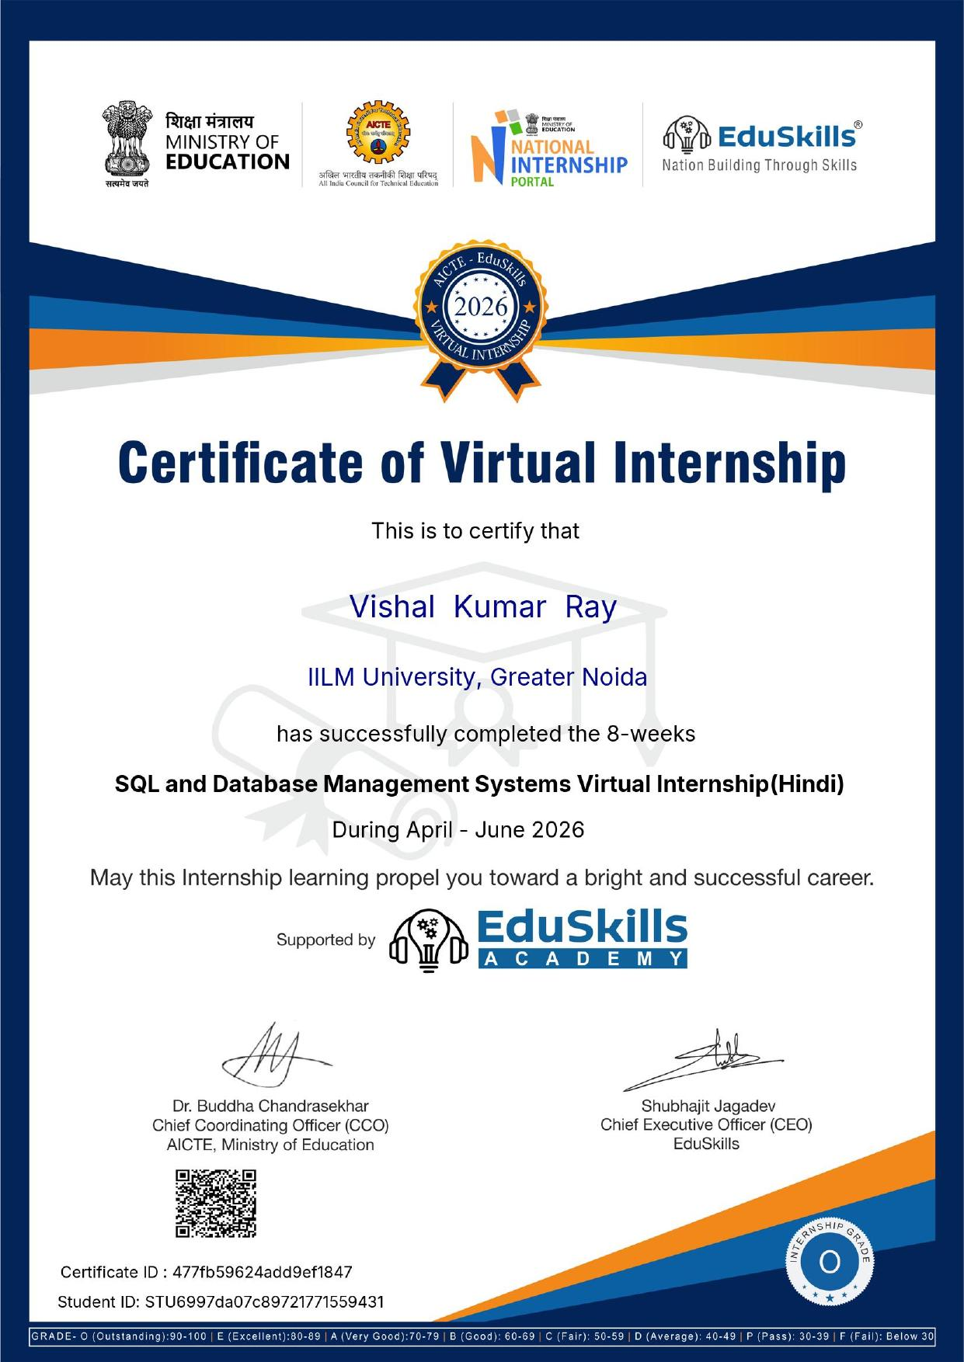

Course Certificate of Internship
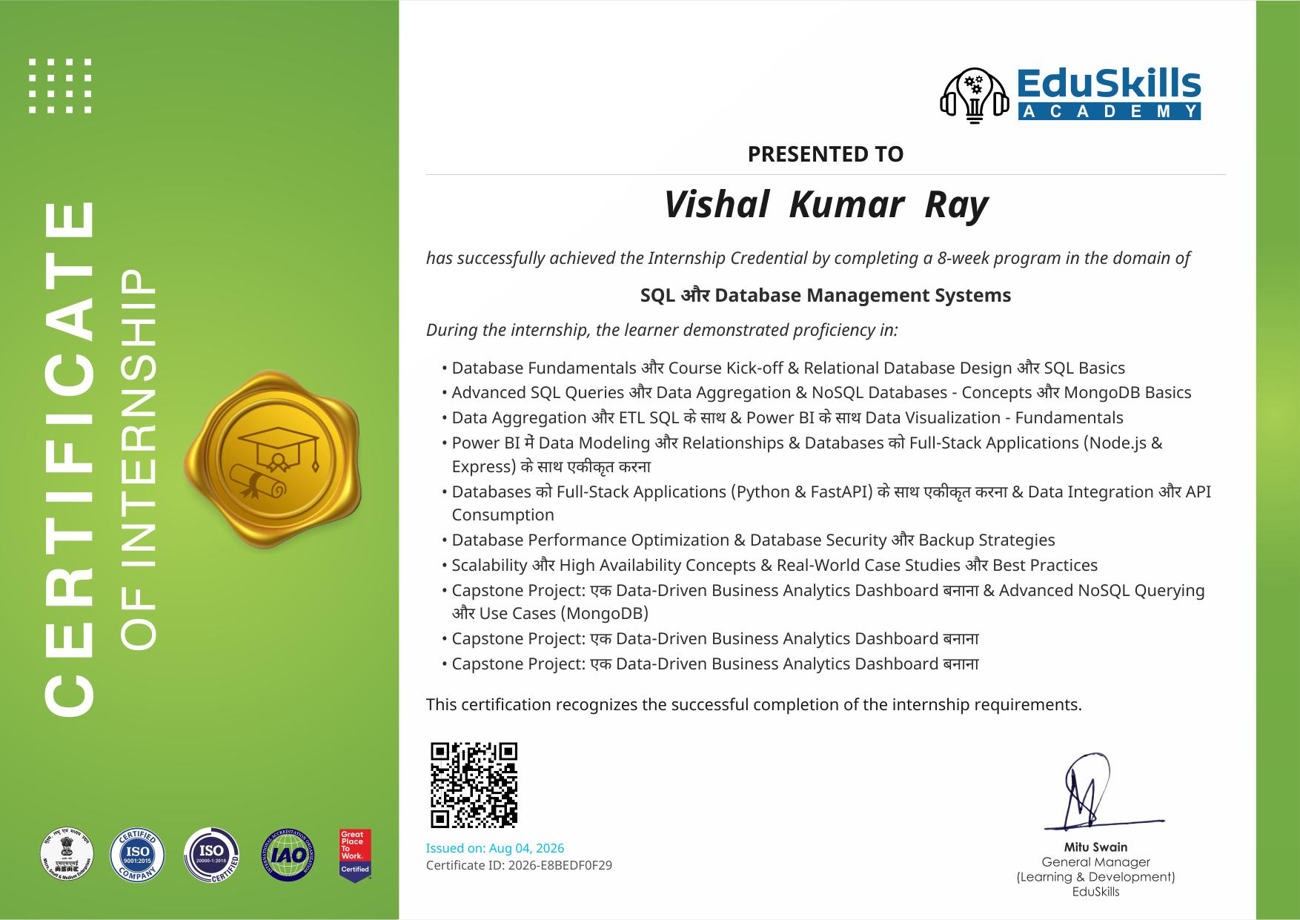

Internship Offer Letter
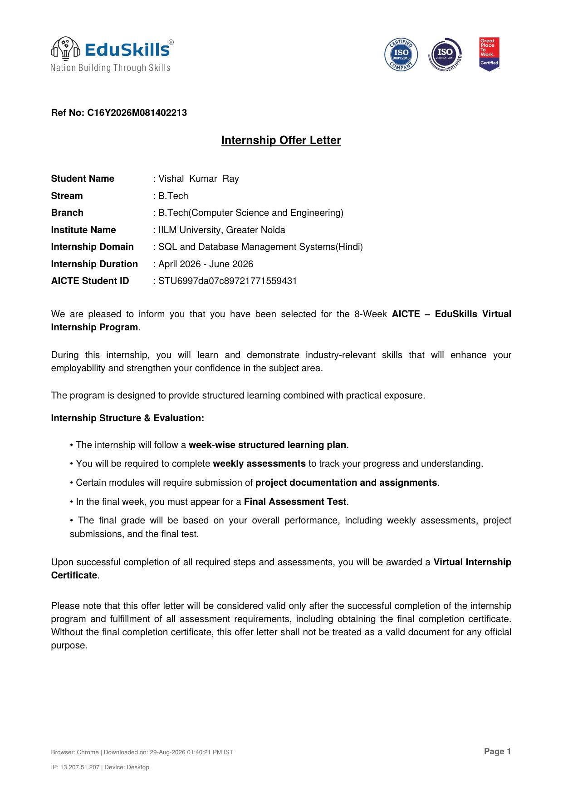

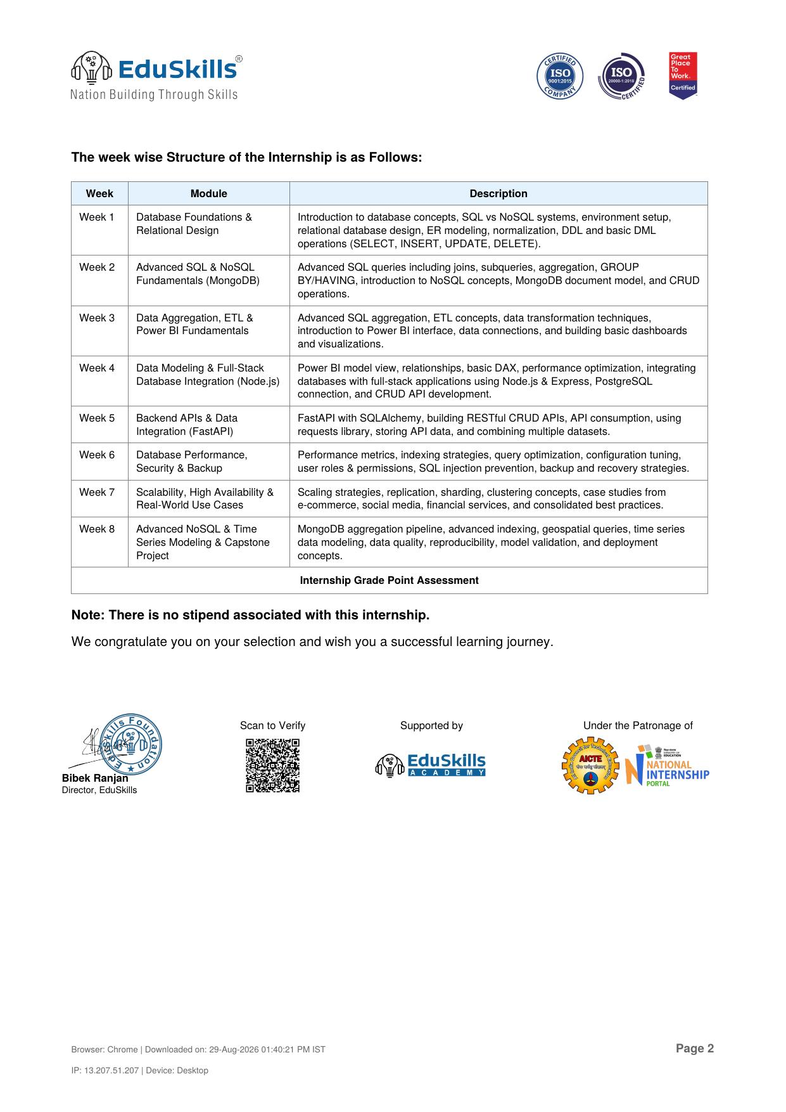

4. PROJECT DESCRIPTION
4.1 Introduction
This report presents a detailed account of the 8-week Virtual Internship undertaken under the AICTE – EduSkills Virtual Internship Program, in the domain of “SQL and Database Management Systems.” The internship was carried out from April 2026 to June 2026 as part of the requirement of the Bachelor of Technology (Computer Science and Engineering) programme at IILM University, Greater Noida. The primary aim of this internship was to bridge the gap between theoretical understanding of relational and non-relational database concepts and their practical, industry-relevant application. Over the course of the programme, the learner was exposed to the complete database lifecycle – from relational design and advanced SQL querying to NoSQL data modeling, business intelligence, full-stack integration, performance tuning, security, and scalability.
The internship followed a structured, week-wise curriculum that combined conceptual learning with hands-on assignments, weekly assessments, project documentation, and a final capstone project. On successful completion of all the requirements, including the final assessment test, a Virtual Internship Certificate was awarded by EduSkills Academy under the patronage of AICTE's National Internship Portal.
4.2 Organization Profile
EduSkills Academy is an ISO 9001:2015 and ISO 20000-1:2018 certified organization working under the theme “Nation Building Through Skills.” EduSkills partners with the All India Council for Technical Education (AICTE) to run the AICTE – EduSkills Virtual Internship Program under the patronage of the AICTE National Internship Portal. The organization collaborates with leading technology companies and academic institutions to design industry-aligned virtual internship curricula that help engineering students strengthen their employability and gain practical exposure to emerging technology domains such as Databases, Cloud Computing, Business Intelligence, and Full-Stack Development, among others.
4.3 Problem Statement
Although a large number of engineering students learn database theory – such as ER modeling, normalization, and basic SQL syntax – during their academic coursework, very few get exposure to the practices required to manage databases in real, production-grade environments. Designing a normalized schema is only one part of the database lifecycle; writing optimized queries, integrating databases into full-stack applications, securing data against threats such as SQL injection, ensuring backup and recovery, and scaling the system for high availability are equally important and often overlooked skills. The problem addressed by this internship was to understand and practically implement the complete lifecycle of database management – from relational and NoSQL design, through ETL and business intelligence, to backend API integration, performance optimization, security, and scalability.
4.4 Project Objectives
- To understand core database concepts, SQL vs NoSQL systems, and perform relational database design through ER modeling and normalization.
- To master advanced SQL queries, including joins, subqueries, aggregation, and GROUP BY/HAVING clauses.
- To learn NoSQL concepts using MongoDB, including its document model and CRUD operations.
- To perform data aggregation and ETL, and build interactive dashboards and visualizations using Power BI.
- To learn data modeling, relationships, and DAX in Power BI, and integrate databases with full-stack applications using Node.js and Express.
- To build RESTful CRUD APIs using FastAPI with SQLAlchemy, and consume external APIs to combine multiple datasets.
- To understand database performance optimization, indexing strategies, user roles and permissions, SQL injection prevention, and backup and recovery strategies.
- To study scalability strategies such as replication, sharding, and clustering through real-world case studies.
- To apply advanced NoSQL concepts, including MongoDB aggregation pipelines, geospatial queries, and time-series data modeling, in a capstone project.
4.5 Scope of the Project
The scope of this internship spans the entire database management lifecycle – starting from relational database design and advanced SQL querying, extending to NoSQL data modeling with MongoDB, data aggregation and ETL for business intelligence dashboards in Power BI, integration of databases with full-stack applications (Node.js/Express and FastAPI), and concluding with performance optimization, security, backup, and scalability practices. It also covers a capstone project involving the design of a data-driven business analytics dashboard combined with advanced NoSQL querying and use cases drawn from e-commerce, social media, and financial services. The internship was limited to a virtual, simulation/lab-based environment provided by EduSkills Academy and did not involve deployment on any live organizational production system.
4.6 Technologies and Tools Used
- Database Systems: SQL (Relational Databases), PostgreSQL, MongoDB (NoSQL)
- Query & Aggregation: Joins, Subqueries, GROUP BY/HAVING, MongoDB Aggregation Pipeline
- Business Intelligence: Microsoft Power BI, DAX, Data Modeling
- Backend & Full-Stack Integration: Node.js, Express.js, FastAPI, SQLAlchemy
- Programming Languages: Python, JavaScript, SQL
- Performance & Security: Indexing strategies, query optimization, role-based access control, SQL injection prevention
- Others: ETL concepts, RESTful APIs, backup and recovery tools, replication and sharding concepts
4.7 System Architecture
The general architecture followed during the internship for building and managing a database-driven solution can be summarized in the following layers:
- Data Layer: Relational databases (SQL/PostgreSQL) and non-relational databases (MongoDB) storing structured and unstructured data.
- Query & Aggregation Layer: Advanced SQL queries (joins, subqueries, aggregation) and MongoDB's aggregation pipeline for data processing.
- ETL & BI Layer: Data extraction, transformation, and loading pipelines feeding Power BI dashboards built with relational data models and DAX measures.
- API Layer: FastAPI with SQLAlchemy and Node.js/Express expose the underlying databases as RESTful CRUD APIs.
- Application Layer: Full-stack applications consume the APIs to perform CRUD operations and display data to end users.
- Security & Performance Layer: Indexing, query optimization, user roles and permissions, SQL injection prevention, and backup/recovery mechanisms protect and optimize the system.
- Scalability Layer: Replication, sharding, and clustering strategies ensure high availability for real-world, large-scale use cases.
4.8 Methodology
The internship followed a structured, week-wise methodology combining conceptual learning, hands-on labs, weekly assessments, and project submissions, as summarized in the table below.
Week | Module | Description
1 | Database Foundations & Relational Design | Introduction to database concepts, SQL vs NoSQL systems, environment setup, relational database design, ER modeling, normalization, DDL and basic DML operations (SELECT, INSERT, UPDATE, DELETE).
2 | Advanced SQL & NoSQL Fundamentals (MongoDB) | Advanced SQL queries including joins, subqueries, aggregation, GROUP BY/HAVING, introduction to NoSQL concepts, MongoDB document model, and CRUD operations.
3 | Data Aggregation, ETL & Power BI Fundamentals | Advanced SQL aggregation, ETL concepts, data transformation techniques, introduction to Power BI interface, data connections, and building basic dashboards and visualizations.
4 | Data Modeling & Full-Stack Database Integration (Node.js) | Power BI model view, relationships, basic DAX, performance optimization, integrating databases with full-stack applications using Node.js & Express, PostgreSQL connection, and CRUD API development.
5 | Backend APIs & Data Integration (FastAPI) | FastAPI with SQLAlchemy, building RESTful CRUD APIs, API consumption, using requests library, storing API data, and combining multiple datasets.
6 | Database Performance, Security & Backup | Performance metrics, indexing strategies, query optimization, configuration tuning, user roles & permissions, SQL injection prevention, backup and recovery strategies.
7 | Scalability, High Availability & Real-World Use Cases | Scaling strategies, replication, sharding, clustering concepts, case studies from e-commerce, social media, financial services, and consolidated best practices.
8 | Advanced NoSQL & Time Series Modeling & Capstone Project | MongoDB aggregation pipeline, advanced indexing, geospatial queries, time series data modeling, data quality, reproducibility, model validation, and deployment concepts.

Each week concluded with a weekly assessment to evaluate conceptual understanding, and selected modules required submission of project documentation and assignments. In the final week, a Final Assessment Test was conducted, and the overall grade was based on performance across weekly assessments, project submissions, and the final test.
4.9 Expected Outcomes
- Ability to design normalized relational database schemas and write advanced SQL queries involving joins, subqueries, and aggregation.
- Practical understanding of NoSQL concepts and hands-on experience with MongoDB's document model, CRUD, and aggregation pipeline.
- Hands-on exposure to ETL processes and building business intelligence dashboards using Power BI and DAX.
- Capability to integrate databases into full-stack applications using Node.js/Express and FastAPI with SQLAlchemy.
- Practical knowledge of database performance optimization, indexing, security hardening, and backup/recovery strategies.
- Understanding of scalability approaches such as replication, sharding, and clustering for high-availability, real-world use cases.
- A completed, end-to-end capstone project demonstrating a data-driven business analytics dashboard with advanced NoSQL querying.
4.10 Certificates of Completion and Communication Proof
The Internship Offer Letter, the Certificate of Virtual Internship, and the Course Certificate of Internship issued by EduSkills Academy, confirming successful completion of the 8-week AICTE – EduSkills Virtual Internship Program in SQL and Database Management Systems, are attached in Chapter 3 of this report.

5. BIBLIOGRAPHY/REFERENCES
1. EduSkills Academy, “AICTE – EduSkills Virtual Internship Program – SQL and Database Management Systems (Hindi),” Internship Offer Letter, Ref No. C16Y2026M081402213, 2026.
2. EduSkills Academy, “Certificate of Virtual Internship – SQL and Database Management Systems,” AICTE Student ID: STU6997da07c89721771559431, 2026.
3. EduSkills Academy, “Certificate of Internship,” Certificate ID: 2026-E8BEDF0F29, Issued on August 04, 2026.
4. PostgreSQL Global Development Group, PostgreSQL Documentation, https://www.postgresql.org/docs/
5. MongoDB, Inc., MongoDB Documentation, https://www.mongodb.com/docs/
6. Microsoft Corporation, Power BI Documentation, https://learn.microsoft.com/power-bi/
7. FastAPI Documentation, https://fastapi.tiangolo.com/
8. Node.js and Express.js official documentation, https://nodejs.org/ and https://expressjs.com/

